Chronos Review

General
Assumption – logic design is correct.

Power supplies

Analog VCCA 1.0 V Power For DPHY And Serdes
U14 TLV73310PDQNT
Footprint should be fixed accordingly to datasheet
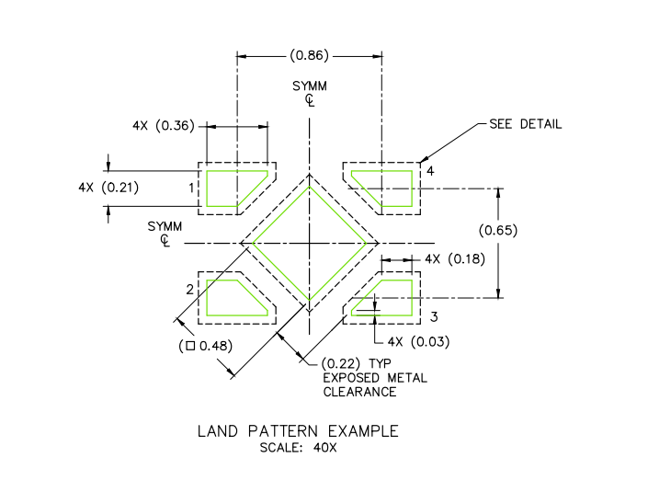

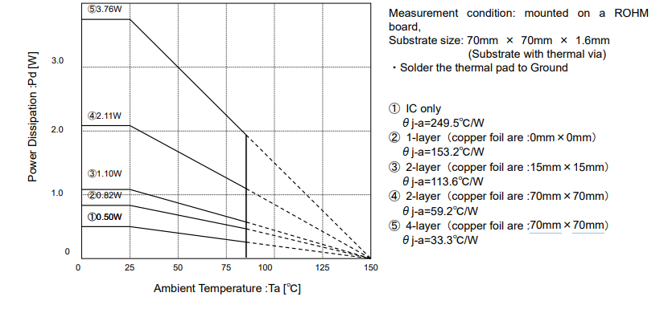
DPHY, Serdes, ADC And VCCAUX Analog 1.8 V Power
U13 BD00IC0WHFV-GTR
Can be used up to 50C when 0.9W is consumed
Can be used up to 75C because of we use 8 layer pcb

5.0V, 3.3V
U15 LT3508EUF - OK

Core Power 1.0V, Core Power 1.8V
U16 LT3508EUF - OK

Power CSI and Banks
- Why not using N-CH FET instead of NPN? It consumes less current and more common
is only used to drive LEDs; it is not necessary

- U11, U12 – Fix footprint according to datasheet

Camera Interface
- I think FB2, FB3, FB9, FB10 are not required. Why not connecting directly to GND?
A ferrite bead is used because it is an analog ground. If no problems are observed during testing, a 0R resistor can be installed.

Config and ADC
- Why not using N-CH FET instead of NPN? It consumes less current and more common
is only used to drive LEDs; it is not necessary

LAYOUT
There are many violations. Most of footprints should be corrected.
Please use the following rules to fix those.
- Solder mask opening for pads shall be 2mil max, 0mil in case of high density.
- Solder mask slivers shall be larger than 3mil
- Clearances:
Clearances are configured according to JLCPCB capabilities
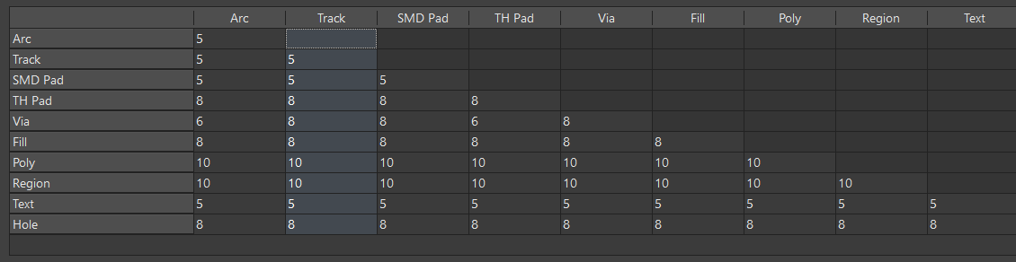

- Clearance from board edge
JLCPCB min board edge clearence is 0.2mm
  - Pads shall be greater than 40mil from edge
  - Copper shall be greater than 20mil from edge

- Polygon connection
  - Via – direct connection
  - Pad – Relief connection
Only the GNDs are connected in relief.
- Minimum angular ring = 5mil
Made according to JLCPCB specifications
- Acute angle = >60
this rule is not working properly
- Silk to solder mask clearance = 5mil
ok

